Improvement of Spatial Dependence in Multi-Site Daily Precipitation Using Multivariate Bias Correction Relative to Quantile Delta Mapping

จุดที่ควรนำ "Coastal Gauge Network in Thailand" ไปใส่แทน
1. ในบทคัดย่อ (Abstract): ระบุในส่วนของ Methodology หรือ Case study ให้ชัดเจนตั้งแต่ประโยคแรกๆ เช่น
"The proposed approach was evaluated using daily precipitation data from a coastal gauge network in Thailand..."
2. คำสำคัญ (Keywords): ดึงคำเฉพาะเกี่ยวกับพื้นที่มาใส่เป็น Keyword เพื่อให้ระบบฐานข้อมูลสืบค้นได้ เช่น
Keywords: Multivariate bias correction, Quantile delta mapping, Spatial dependence, Coastal gauge network, Thailand
3. ในเนื้อหาบทความ (Main Body):
Introduction: ระบุในย่อหน้าสุดท้ายที่สรุปวัตถุประสงค์งานวิจัย
Materials and Methods / Study Area: สร้างหัวข้อย่อยเฉพาะสำหรับอธิบายลักษณะภูมิประเทศ จำนวนสถานี และช่วงเวลาของข้อมูลในเครือข่ายสถานีชายฝั่งของไทย

Multivariate Bias Correction Improves Inter-Station Dependence Relative to QDM in Multi-Site Daily Precipitation across a Coastal Gauge Network in Thailand
Surasit Punyawansiri^{1,*}
¹Office of Water Management and Hydrology, Royal Irrigation Department, Bangkok, Thailand
*Corresponding author: Surasit.pun@thaimooc.ac.th

Abstract
Climate-model precipitation bias correction is often evaluated independently at each gauge, although distributed hydrological applications also require realistic spatial dependence. We compared quantile delta mapping (QDM), N-dimensional multivariate bias correction (MBCn), and raw CMIP6 precipitation for 12 rain gauges in Prachuap Khiri Khan, Thailand, using seven CMIP6 models. Parameters were fitted for 1981–2000 and evaluated independently for 2001–2014. The revised pipeline locked all multivariate operations to the 12 specified gauges and applied monthly-block MBCn with 25 seeded orthogonal-rotation passes. QDM and MBCn therefore had identical single-site diagnostics, whereas MBCn reduced standardized energy distance from 0.139 to 0.104, Spearman RMSE from 0.286 to 0.157, Pearson RMSE from 0.374 to 0.124, and wet-day occurrence RMSE from 0.273 to 0.111. All seven models favoured MBCn for the three primary correlation endpoints (exact one-sided Wilcoxon p = 0.0078; Holm-adjusted p = 0.0234). Normalized joint-q95 RMSE also improved in all models. However, temporal diagnostics showed trade-offs in wet/dry persistence and Rx5day. Future wet-day quantile-change fidelity was broadly comparable, with mean absolute deviation from raw model signals of 9.66 percentage points for MBCn and 10.32 for QDM. MBCn is therefore better supported when inter-station dependence is an explicit objective, provided temporal consequences are also assessed.
Keywords: multivariate bias correction, MBCn, inter-station dependence, multi-site precipitation, CMIP6

1. Introduction
Global climate models are indispensable for climate-impact assessment, but their spatial resolution and systematic precipitation biases limit direct use at station and catchment scales [1], [2], [3], [4], [5], [6]. Statistical bias correction is therefore widely used, although its validity depends on the intended application and on whether corrected series retain physically relevant changes [7], [8].
Quantile delta mapping (QDM) corrects the marginal distribution while retaining model-projected changes in quantiles and extremes [9]. It is effective for station-wise applications, but independent univariate corrections do not constrain dependence among gauges. This matters for distributed hydrological modelling, spatially concurrent hazards, and compound events, for which accurate marginals can coexist with unrealistic joint behaviour [10], [11], [12], [13], [14], [15], [16], [17], [18].
Multivariate approaches explicitly modify the joint distribution. Correlation-targeted multivariate bias correction [10], N-dimensional MBCn [11], rank-resampling methods [12], and optimal-transport corrections [13] provide alternative strategies, while comparative studies show method-specific benefits and losses [14], [15]. The present study follows the validation principle that method performance should be assessed against the scientific use case rather than by a single metric [7].
The CMIP6 framework provides coordinated historical and future simulations [1], while ScenarioMIP and the Shared Socioeconomic Pathways define internally consistent future forcing pathways [2], [3]. Previous studies over mainland Southeast Asia and Thailand have demonstrated substantial model and scenario dependence in precipitation and extremes [19], [20], [21], [22], [23], [24], [25], [26], [27].
This study therefore asks how much MBCn improves inter-station dependence after marginal performance has been fixed by QDM, how stable that improvement is to iteration count and stochastic seed, and whether multivariate correction alters temporal structure or projected precipitation-change fidelity. The analysis uses independent validation and multiple complementary diagnostics [28], [29], [30], [31].

2. Materials and Methods

2.1 Study area and rain-gauge network
Twelve daily rain gauges in Prachuap Khiri Khan Province, on the western shore of the Gulf of Thailand, were used as the observed network (Table 1 and Figure 1). The records cover 1 January 1981 to 31 December 2014. Mean annual precipitation ranges from approximately 944 to 1,376 mm, while wet-day frequency varies substantially among gauges. The final analysis uses exactly the 12 stations specified in the manuscript: 500001, 500002, 500003, 500004, 500005, 500006, 500007, 500008, 500009, 500201, 500202, and 500301. The source archive contains additional stations, but these were excluded before fitting and before every multivariate operation.
Coordinates and elevations were taken from the project station metadata and filtered to the same 12-station network. Figure 1 provides geographic context only; elevation is not used as a predictor in the bias-correction procedure. The observed Prachuap Khiri Khan subset contains 12,418 daily records over the study period and is gap-free for the 12 selected gauges.
Seven CMIP6 models were analysed: ACCESS-ESM1-5, CanESM5, CESM2, EC-Earth3, FGOALS-g3, MIROC6, and MRI-ESM2-0. The selected model files provide daily precipitation at the gauge locations for the historical period and SSP2-4.5 and SSP5-8.5 pathways. CESM2 uses r11i1p1f1; the other six models use r1i1p1f1. The use of multiple models is intended to characterize methodological consistency across a specified ensemble, not to treat the models as statistically independent samples [4], [32], [22].
A common temporal split was applied: 1981–2000 for calibration and 2001–2014 for independent validation. Validation observations were not used in fitting. Historical corrected series cover 1981–2014 and future corrected series cover 2015–2100; future results are summarized for 2021–2040, 2041–2060, and 2081–2100. SSP2-4.5 and SSP5-8.5 are interpreted as scenario pathways rather than probabilistic forecasts [5], [6].
Station | Latitude (°N) | Longitude (°E) | Elevation (m) | Mean annual rainfall (mm) | Wet-day frequency (%)
500001 | 12.370 | 99.950 | 8 | 983.70 | 22.23
500002 | 11.180 | 99.550 | 0 | 1,376.20 | 33.73
500003 | 12.020 | 99.900 | 0 | 1,100.00 | 22.93
500004 | 11.470 | 99.650 | 0 | 1,106.00 | 26.34
500005 | 11.600 | 99.680 | 6 | 1,147.20 | 47.96
500006 | 11.620 | 99.670 | 24 | 1,203.10 | 49.77
500007 | 11.900 | 99.780 | 24 | 1,133.60 | 48.66
500008 | 12.530 | 99.550 | 128 | 1,206.30 | 62.63
500009 | 12.220 | 99.870 | 13 | 1,176.50 | 60.15
500201 | 11.830 | 99.830 | 64 | 1,108.20 | 24.70
500202 | 12.590 | 99.960 | 0 | 944.10 | 21.53
500301 | 12.580 | 99.730 | 106 | 1,064.80 | 25.33
Coordinates (WGS84) and elevations are from the project metadata archive; rainfall statistics are computed from the gap-free observed daily record. A wet day is defined throughout as at least 1 mm of rainfall.
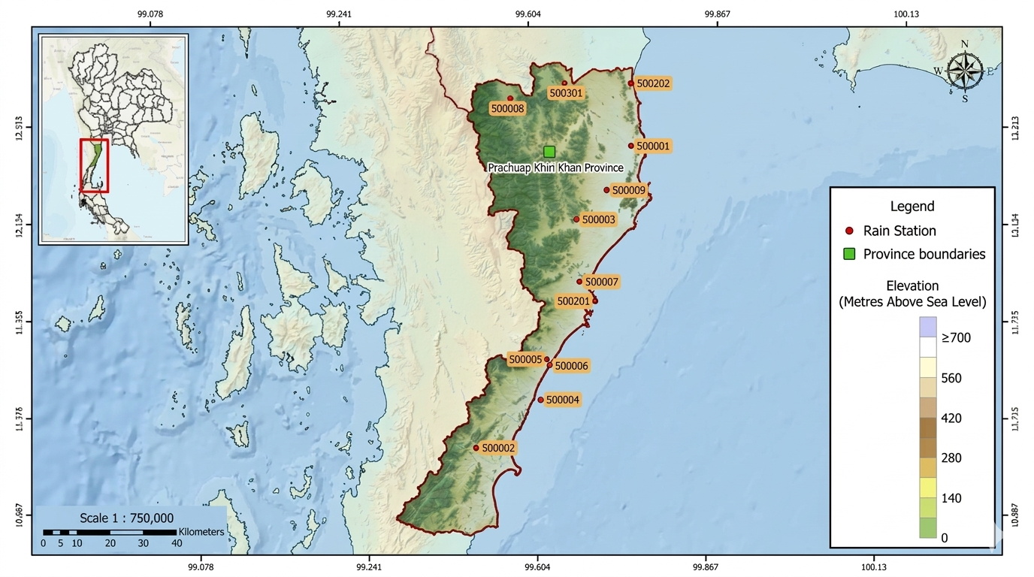
Figure 1. Location of the 12 selected rain gauges in Prachuap Khiri Khan Province, Thailand. Labels identify the stations used in every fitting and evaluation step.

2.2 Climate models and experimental design
Seven CMIP6 models were analysed: ACCESS-ESM1-5, CanESM5, CESM2, EC-Earth3, FGOALS-g3, MIROC6, and MRI-ESM2-0. The selected model files provide daily precipitation at the gauge locations for the historical period and the SSP2-4.5 and SSP5-8.5 pathways. CESM2 uses r11i1p1f1; the other six models use r1i1p1f1. All model fields were restricted to the same 12 station identifiers before fitting or evaluation.
A common temporal split was applied to every method: 1981–2000 for calibration and 2001–2014 for independent validation. Validation observations were not used in fitting. Historical and future corrected series were generated for 1981–2014 and 2015–2100, respectively. Future periods were summarized as near future (2021–2040), mid-century (2041–2060), and late century (2081–2100).

Model | Institution | Ensemble member | Grid label
ACCESS-ESM1-5 | CSIRO, Australia | r1i1p1f1 | gn
CanESM5 | CCCma, Canada | r1i1p1f1 | gn
CESM2 | NCAR, United States | r11i1p1f1 | gn
EC-Earth3 | EC-Earth Consortium, Europe | r1i1p1f1 | gr
FGOALS-g3 | CAS, China | r1i1p1f1 | gn
MIROC6 | MIROC, Japan | r1i1p1f1 | gn
MRI-ESM2-0 | MRI, Japan | r1i1p1f1 | gn
Table 2. The seven CMIP6 models and their configuration.
All seven models provide daily precipitation for the historical experiment (1981–2014) and for both SSP2-4.5 and SSP5-8.5. Labels were verified against the archive filenames. gn = native model grid; gr = regridded.

2.3 Bias-correction methods
Quantile delta mapping (QDM) was applied independently to each gauge and calendar month. Let F_o and F_m denote the empirical cumulative distribution functions of observed and simulated precipitation during calibration. For a simulated value x, its model quantile is mapped to the corresponding observed distribution and adjusted relative to the model baseline according to Cannon et al. [13]. The monthly formulation avoids mixing markedly different seasonal precipitation regimes and is consistent with established distribution-based correction practice [16], [12].
$$\begin{matrix} & u=F_{m}\left(x\right), & & \text{(1)}\end{matrix}$$
and the corresponding observed quantile was obtained from the inverse observed distribution. For relative QDM, the bias-corrected value was calculated as
$$\begin{matrix} & x_{QDM}=F_{o}^{-1}\left(u\right)\frac{x}{F_{m,b}^{-1}\left(u\right)}, & & \text{(2)}\end{matrix}$$
MBCn was initialized with the QDM-corrected precipitation field and applied to the 12-dimensional station vector [11]. Each calendar month was processed separately. Observed and model calibration blocks were aligned by date and restricted to complete 12-station rows. The observed calibration field was standardized using station-specific mean and standard deviation, followed by deterministic random orthogonal rotation, component-wise quantile mapping in rotated space, inverse rotation, and 25 passes using seed 42. This follows the iterative rotation-and-mapping principle of MBCn and is consistent with regional applications of multivariate correction [33].
MBCn was initialized with the QDM-corrected precipitation field and then applied iteratively to the 12-dimensional station vector [11]. In the revised Q2.1 implementation, the adjustment is performed separately for each calendar month to avoid mixing the strongly seasonal precipitation regimes of the study area. For each month, observed calibration data and model calibration data are aligned by date and restricted to complete 12-station rows. The observed calibration field is standardized using its station-specific mean and standard deviation. A deterministic random orthogonal rotation is then applied, each rotated component is quantile-mapped using calibration data only, and the inverse rotation is applied. This process is repeated for 25 passes using seed 42, with month-specific deterministic random streams.
$$\begin{matrix} & Z^{\left(k\right)}=P^{\left(k\right)}R^{\left(k\right)}, R^{\left(k\right)}{R^{\left(k\right)}}^{T}=I, & & \text{(3)}\end{matrix}$$
After the iterative adjustment, the QDM marginal value set is restored within each calendar month by rank substitution. This construction means that MBCn changes the joint arrangement of precipitation values across stations while preserving the supplied QDM marginal sample within each month. Consequently, equality of station-level diagnostics is an expected algorithmic property; it is not evidence that MBCn has no effect on the joint field.
After the iterative adjustment, the QDM marginal value set was restored within each calendar month by rank substitution. Thus MBCn changes the joint arrangement across stations while preserving the supplied QDM marginal sample. Equality of station-level diagnostics is therefore an algorithmic property, not evidence that the multistation fields are identical [14], [19]. All mappings were fitted using 1981–2000 only; the 2001–2014 observations were withheld until validation. A wet day is defined as precipitation ≥1 mm.
For dependence-focused concurrent extremes, station-specific wet-day 95th percentiles are used within each method and joint exceedance is normalized by the corresponding marginal exceedance probabilities. An observed-threshold version is retained as a hazard-oriented sensitivity analysis. Energy distance is calculated after station-wise standardization using observed calibration scale parameters, giving a dimensionless multivariate discrepancy [24], [34].
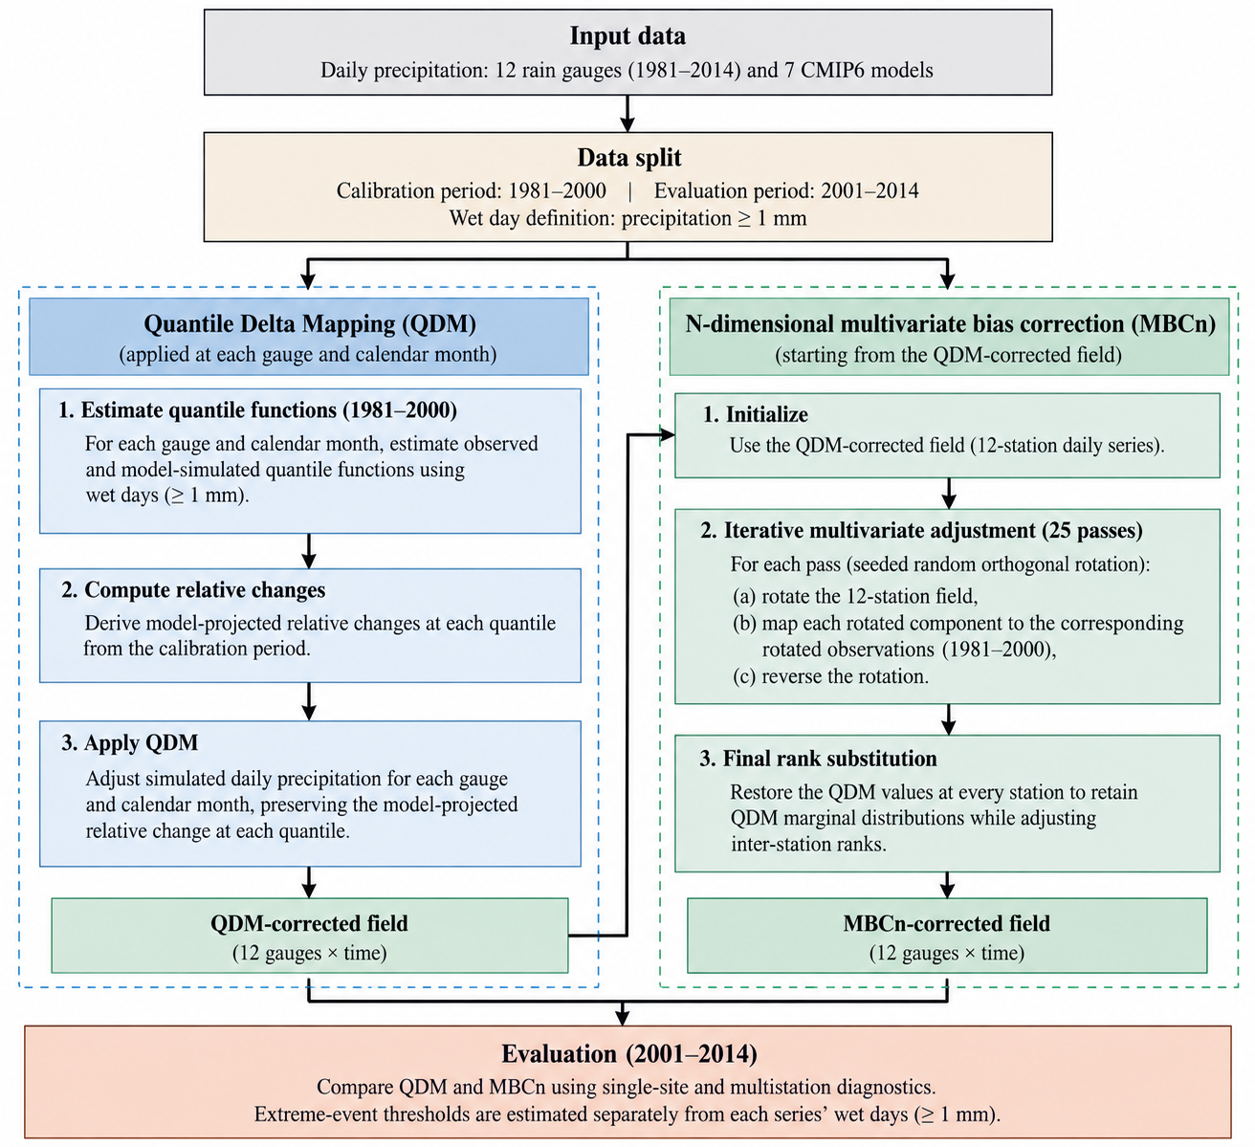
Figure 2. Revised MBCn workflow. QDM establishes station-level monthly marginal distributions; monthly-block rotation, rotated-space quantile mapping, and inverse rotation adjust the joint arrangement; final within-month rank substitution restores the QDM value set.

2.4 Single-site diagnostics
Because free-running climate simulations are not expected to reproduce the timing of individual observed rainfall events, model performance was evaluated using distributional rather than day-matched diagnostics. For each of the 84 gauge–model combinations, six complementary metrics were calculated over the independent validation period: percentage bias in total precipitation (PBIAS), wet-day-frequency error, the ratio of simulated to observed wet-day standard deviation (SD ratio), Perkins skill score (PSS), Kolmogorov–Smirnov (KS) distance, and the root mean square error (RMSE) of matched wet-day quantiles. The diagnostics were selected to assess complementary aspects of precipitation amount, occurrence, variability, distributional shape, and quantile agreement. Perkins skill score follows the probability-density-overlap approach of Perkins et al. [29].
A wet day was defined as a day with precipitation ≥1 mm. Let $O_{t}$and $M_{t}$denote observed and simulated precipitation on day $t$, respectively, and let $N$be the number of validation days. Total-precipitation bias was expressed as
$$\begin{matrix} & PBIAS=100 \frac{\sum_{t=1}^{N}{M_{t}}-\sum_{t=1}^{N}{O_{t}}}{\sum_{t=1}^{N}{O_{t}}}, & & \text{(4)}\end{matrix}$$
where values close to zero indicate smaller bias; positive and negative values indicate overestimation and underestimation, respectively.
Wet-day-frequency error was calculated in percentage points as
$$\begin{matrix} & E_{wet}=100\left(\frac{N_{M}^{wet}}{N}-\frac{N_{O}^{wet}}{N}\right), & & \text{(5)}\end{matrix}$$
where $N_{M}^{wet}$and $N_{O}^{wet}$are the numbers of simulated and observed wet days, respectively. The wet-day standard-deviation ratio was defined as
$$\begin{matrix} & R_{SD}=\frac{σ_{M}^{wet}}{σ_{O}^{wet}}, & & \text{(6)}\end{matrix}$$
where $σ_{M}^{wet}$and $σ_{O}^{wet}$are the standard deviations of simulated and observed precipitation restricted to wet days. A value of one therefore indicates agreement in wet-day variability.
To evaluate the overall distributional shape, the Perkins skill score was calculated from the simulated and observed precipitation probability distributions using common bins:
$$\begin{matrix} & PSS=\sum_{k=1}^{K}{min}\left(p_{M,k} , p_{O,k}\right), & & \text{(7)}\end{matrix}$$
where $p_{M,k}$and $p_{O,k}$are the simulated and observed probabilities in precipitation bin $k$, and $K$is the total number of common bins. PSS ranges from 0 to 1, with values closer to 1 indicating greater overlap between the two distributions. For distributional agreement based on the cumulative distribution functions (CDFs), the KS distance was calculated as
$$\begin{matrix} & D_{KS}=\sup_{x}∣F_{M}\left(x\right)-F_{O}\left(x\right)∣, & & \text{(8)}\end{matrix}$$
where $F_{M}\left(x\right)$and $F_{O}\left(x\right)$are the simulated and observed CDFs, respectively. Lower values indicate closer agreement.
Finally, agreement across the magnitude range of wet-day precipitation was evaluated using matched quantiles. For a set of quantile probabilities $p_{j}$, $j=1,…,J$, the quantile RMSE was calculated as
$$\begin{matrix} & {RMSE}_{q}=\sqrt{\frac{1}{J}\sum_{j=1}^{J}{{\left[Q_{M}\left(p_{j}\right)-Q_{O}\left(p_{j}\right)\right]}^{2}}}, & & \text{(9)}\end{matrix}$$
where $Q_{M}\left(p_{j}\right)$and $Q_{O}\left(p_{j}\right)$are the simulated and observed wet-day quantiles at probability $p_{j}$. Lower values indicate closer agreement in precipitation magnitude across the selected quantiles.
Together, these metrics provide a distribution-based assessment without requiring correspondence between simulated and observed rainfall on the same calendar day. Day-matched error measures were therefore not used, as they would confound distributional model skill with differences in the timing of weather events that free-running climate simulations are not designed to reproduce. This distribution-focused evaluation is also consistent with the use of probability distributions and precipitation-frequency characteristics in previous climate-model evaluations.

2.5 Dependence diagnostics and statistical testing
Because free-running GCMs are not expected to reproduce the exact timing of individual observed rainfall events, validation emphasizes distributional rather than day-matched diagnostics [21], [22]. Six metrics are calculated for each of the 84 gauge–model combinations: PBIAS, wet-day-frequency error, wet-day SD ratio, Perkins skill score, Kolmogorov–Smirnov distance, and wet-day quantile RMSE. These metrics assess amount, occurrence, variability, distributional shape, and quantile agreement [22], [23].
Perkins skill score follows the probability-density-overlap approach of Perkins et al. [23]. The KS distance follows standard empirical-CDF comparison [22]. Wet-day quantiles are evaluated at fixed probabilities using the same quantile definition for observations and simulations. The framework is consistent with established downscaling-validation guidance [21] and avoids interpreting timing errors as distributional model error.
$$\begin{matrix} & D_{E}=2 E∥X-Y∥-E∥X-X^{'}∥-E∥Y-Y^{'}∥, & & \text{(10)}\end{matrix}$$
Spatial dependence is evaluated over the independent 2001–2014 validation period. The three prespecified primary endpoints are RMSE of the inter-station Spearman correlation matrix, Pearson correlation matrix, and binary wet-day correlation matrix. Secondary diagnostics are standardized energy distance, normalized concurrent-q95 RMSE, observed-threshold q95 RMSE, and Wasserstein-1 distance of daily wet-station extent. Pairwise dependence is evaluated over the 66 unique off-diagonal station pairs. Energy distance is an omnibus joint-distribution measure [24], [34], while Wasserstein distance provides a distributional discrepancy for network-scale wet extent [31].
Dependence among stations was further evaluated from the three $12×12$correlation matrices: Spearman rank correlation, Pearson correlation, and binary wet-day correlation. Because the diagonal elements represent self-correlations and do not contain information about inter-station dependence, only the 66 unique off-diagonal station pairs were evaluated. For a given correlation measure $r$, the corresponding matrix RMSE was calculated as
$$\begin{matrix} & {RMSE}_{r}={\left[\frac{1}{66}\sum_{i<j}{{\left(r_{ij}^{M}-r_{ij}^{O}\right)}^{2}}\right]}^{1/2}, & & \text{(11)}\end{matrix}$$
where $r_{ij}^{M}$and $r_{ij}^{O}$denote the simulated and observed correlations for station pair $\left(i , j\right)$, respectively. For the wet-day correlation, precipitation at each station was converted to a binary indicator
$$\begin{matrix} & W_{ti}=\left\{\begin{matrix}1, & P_{ti}≥1 mm, \\ 0, & P_{ti}<1 mm,\end{matrix}\right. & & \text{(12)}\end{matrix}$$
consistent with the wet-day definition used throughout the analysis. The resulting binary series were then used to calculate pairwise correlations. The three correlation-based RMSEs were treated as the prespecified primary dependence endpoints, consistent with the statistical testing framework of the study.
Concurrent precipitation extremes were evaluated in two ways. The primary dependence-focused metric uses each station's own method-specific 95th wet-day percentile and normalizes the observed and simulated joint exceedance probability by the corresponding marginal exceedance probabilities. This reduces sensitivity to residual differences in individual-station extreme frequency. A second sensitivity metric uses the observed station-specific 95th wet-day thresholds for all methods and is interpreted as a hazard-oriented measure. The two metrics are reported separately because they answer different scientific questions.
$$\begin{matrix} & J_{ij}=\frac{1}{N}\sum_{t=1}^{N}{I}\left(P_{ti}>q_{i,0.95}\right)I\left(P_{tj}>q_{j,0.95}\right), & & \text{(13)}\end{matrix}$$
where $q_{i,0.95}$and $q_{j,0.95}$are the station-specific 95th percentiles of wet-day precipitation and $I\left(⋅\right)$is the indicator function. The corresponding discrepancy was summarized over the 66 station pairs as
All dependence diagnostics are negatively oriented, so smaller values indicate closer agreement. Seven model-level scores are retained and compared as matched pairs. The seven GCMs are not treated as a random population. A one-sided exact Wilcoxon signed-rank test is applied to the paired QDM–MBCn differences [26]. Matched-pairs rank-biserial correlation summarizes effect direction and magnitude. Holm–Bonferroni adjustment is applied only to the three prespecified primary correlation endpoints [25], [26].
This metric evaluates whether the correction method reproduces the spatial occurrence of concurrent heavy precipitation rather than the frequency of extreme precipitation at individual stations. The use of each station's own 95th wet-day percentile follows the study design and minimizes the influence of residual marginal differences on the dependence assessment.
At the network scale, the spatial extent of daily wet conditions was represented by the number of stations recording precipitation of at least 1 mm on each day,
$$\begin{matrix} & {RMSE}_{J}={\left[\frac{1}{66}\sum_{i<j}{{\left(J_{ij}^{M}-J_{ij}^{O}\right)}^{2}}\right]}^{1/2}. & & \text{(14)}\end{matrix}$$
$$\begin{matrix} & H_{t}=\sum_{i=1}^{12}{I}\left(P_{ti}≥1 mm\right). & & \text{(15)}\end{matrix}$$
The distributions of $H_{t}$from the simulations and observations were compared using the Wasserstein-1 distance,
$$\begin{matrix} & W_{1}\left(F_{M} , F_{O}\right)=\int_{-∞}^{∞}{∣F_{M}\left(h\right)-F_{O}\left(h\right)∣} dh, & & \text{(16)}\end{matrix}$$
where $F_{M}$and $F_{O}$are the empirical cumulative distribution functions of daily wet-station extent for the simulated and observed fields, respectively. Lower values indicate closer agreement in the spatial coverage of wet conditions. This network-scale metric complements the pairwise joint-exceedance measure by evaluating the overall distribution of wet-station extent rather than the identity of particular station pairs.
All dependence diagnostics are negatively oriented, so smaller values indicate closer agreement. Seven model-level scores were retained and compared as matched pairs. The seven GCMs are not treated as a random population; the paired tests therefore describe consistency within this specified ensemble rather than population-level inference [1], [19], [22].
Robustness was assessed using an iteration sweep from 0 to 100 passes and a 20-seed sensitivity experiment on ACCESS-ESM1-5, MIROC6, and MRI-ESM2-0. The production setting of 25 passes and seed 42 was fixed a priori rather than selected by minimizing validation error. Temporal structure was assessed using occurrence autocorrelation at lags 1, 3, 7, and 30 days, wet-to-wet and dry-to-dry transitions, CDD, CWD, and Rx5day. These checks follow recent evidence that no correction method is uniformly superior across marginal, dependence, and temporal properties [35], [32], [8].
$$\begin{matrix} & d_{m}=S_{m}^{QDM}-S_{m}^{MBCn}, m=1,…,7, & & \text{(17)}\end{matrix}$$
so that positive values indicate improvement with MBCn. A one-sided exact Wilcoxon signed-rank test was applied to the seven paired differences [36]. The analysis tests within-ensemble consistency rather than inference to a broader population. The matched-pairs rank-biserial correlation summarizes effect direction and magnitude,
$$\begin{matrix} & r_{rb}=\frac{W^{+}-W^{-}}{W^{+}+W^{-}}, & & \text{(18)}\end{matrix}$$
where and are the sums of the positive and negative signed ranks, respectively. Values approaching indicate that the paired differences consistently favour MBCn under the definition in Eq. (18). The number of models for which MBCn produced the lower diagnostic value was also reported to make the direction of the model-level comparison explicit. In the present seven-model ensemble, this paired framework yielded a maximum possible rank-biserial effect size when all models favoured MBCn.
Because Spearman, Pearson, and wet-day-correlation RMSE were prespecified as the primary correlation endpoints, their one-sided p-values were adjusted within this three-test family using the Holm–Bonferroni procedure [37]. Standardized energy distance, normalized joint-q95 RMSE, observed-threshold q95 RMSE, and wet-extent W₁ were treated as secondary or sensitivity diagnostics. Bootstrap uncertainty is interpreted cautiously because dependence among station pairs limits the effective sample size [35].
$$\begin{matrix} & p_{\left(i\right)}^{ adj}=\min\left[1 , \max_{k≤i}\left\{\left(m-k+1\right)p_{\left(k\right)}\right\}\right]. & & \text{(19)}\end{matrix}$$
The projected change signal was assessed using five wet-day precipitation quantiles. For each gauge, model, pathway, future period, and quantile, percentage change was calculated relative to the 1981–2000 baseline. The deviation between corrected and raw model change signals was summarized by mean absolute deviation and R². This follows the principle that bias correction should not be judged only by historical fit and should be checked for unintended alteration of the climate-change signal [9], [13], [8].

2.6 Robustness checks
Robustness was assessed using an iteration sweep from 0 to 100 passes, with zero passes representing QDM, and a random-seed sensitivity experiment using 20 seeds on the three prespecified GCMs (ACCESS-ESM1-5, MIROC6, and MRI-ESM2-0). The production configuration of 25 passes and seed 42 was fixed a priori and was not selected by minimizing validation error. Temporal structure was additionally evaluated using occurrence autocorrelation at lags 1, 3, 7, and 30 days, wet-to-wet and dry-to-dry transition probabilities, mean annual CDD and CWD, and mean annual Rx5day. Seasonal dependence was evaluated separately for DJF, MAM, JJA, and SON.
The preservation of the model-projected precipitation-change signal was assessed using five selected wet-day precipitation quantiles. For each gauge, climate model, pathway, future period, and quantile $p$, the projected percentage change was calculated as
$$\begin{matrix} & ΔQ_{p}=100\left(\frac{Q_{p,f}-Q_{p,b}}{Q_{p,b}}\right), & & \text{(20)}\end{matrix}$$
where $Q_{p,b}$and $Q_{p,f}$denote the $p$-th wet-day precipitation quantiles during the baseline and future periods, respectively.
The deviation of the bias-corrected change signal from the corresponding raw model signal was quantified using the mean absolute deviation (MAD):
$$\begin{matrix} & MAD=\frac{1}{N}\sum_{i=1}^{N}{∣ΔQ_{p,i}^{C}-ΔQ_{p,i}^{R}∣}, & & \text{(21)}\end{matrix}$$
where $ΔQ_{p,i}^{C}$and $ΔQ_{p,i}^{R}$are the projected percentage changes after bias correction and from the raw climate-model output, respectively, and $N$is the total number of gauge–model–pathway–period–quantile combinations.
Agreement between the corrected and raw projected changes was additionally quantified using the coefficient of determination:
$$\begin{matrix} & R^{2}=1-\frac{\sum_{i=1}^{N}{{\left(ΔQ_{p,i}^{C}-ΔQ_{p,i}^{R}\right)}^{2}}}{\sum_{i=1}^{N}{{\left(ΔQ_{p,i}^{R}-\overset{‾}{ΔQ_{p}^{R}}\right)}^{2}}}, & & \text{(22)}\end{matrix}$$
where $\overset{‾}{ΔQ_{p}^{R}}$is the mean raw projected percentage change across all comparison cases.
These robustness analyses assess numerical stability, sensitivity to stochastic initialization, temporal consequences, seasonal dependence, and preservation of the model-projected precipitation-change signal. They do not constitute validation of future climate projections against observations.

3. Results and Discussion

3.1 Single-site performance is identical between the two corrections
The independent validation confirms the station-level behaviour expected from the revised implementation. Across 84 gauge–model combinations, the raw model output had mean PBIAS of 1.39 ± 34.71%, wet-day-frequency error of 10.56 ± 17.24 percentage points, wet-day SD ratio of 0.686 ± 0.491, PSS of 0.824 ± 0.099, KS distance of 0.221 ± 0.104, and wet-day quantile RMSE of 7.83 ± 4.16 mm d⁻¹. QDM reduced the KS distance to 0.101 ± 0.060 and increased PSS to 0.915 ± 0.053; wet-day SD ratio approached unity at 0.985 ± 0.361. Residual total-precipitation and occurrence biases remained, with PBIAS of −17.15 ± 20.82% and wet-day-frequency error of −6.35 ± 12.30 percentage points.
The independent validation confirms the expected station-level behaviour. Across 84 gauge–model combinations, raw output had mean PBIAS of 1.39 ± 34.71%, wet-day-frequency error of 10.56 ± 17.24 percentage points, wet-day SD ratio of 0.686 ± 0.491, PSS of 0.824 ± 0.099, KS distance of 0.221 ± 0.104, and wet-day quantile RMSE of 7.83 ± 4.16 mm d⁻¹. QDM reduced KS distance to 0.101 ± 0.060 and increased PSS to 0.915 ± 0.053; wet-day SD ratio approached unity at 0.985 ± 0.361. Residual total-precipitation and occurrence biases remained. This pattern is consistent with the expected role of QDM in improving marginal distributions while not guaranteeing process realism [9], [13], [21], [8].
QDM and MBCn produced identical values for all six station-level validation diagnostics to numerical precision because the final monthly rank-substitution step restores the QDM value set at each gauge. This is consistent with the construction of MBCn and means that the scientific distinction between QDM and MBCn must be evaluated using joint and temporal diagnostics [11], [14], [19], [32].
Method | PBIAS (%) | Wet-day frequency error (pp) | SD ratio (–) | PSS (–) | KS distance (–) | Quantile RMSE (mm d⁻¹)
RAW | 1.39 ± 34.71 | 10.56 ± 17.24 | 0.686 ± 0.491 | 0.824 ± 0.099 | 0.221 ± 0.104 | 7.83 ± 4.16
QDM | −17.15 ± 20.82 | −6.35 ± 12.30 | 0.985 ± 0.361 | 0.915 ± 0.053 | 0.101 ± 0.060 | 4.08 ± 3.05
MBCn | −17.15 ± 20.82 | −6.35 ± 12.30 | 0.985 ± 0.361 | 0.915 ± 0.053 | 0.101 ± 0.060 | 4.08 ± 3.05
Table 3. Station-level skill over the withheld validation period (mean ± SD, n = 84 gauge–model pairs). QDM and MBCn are identical because the revised MBCn implementation restores the QDM value set within each calendar month.
pp = percentage points; PSS = Perkins skill score; KS = Kolmogorov–Smirnov; SD ratio is the corrected-to-observed ratio of the wet-day standard deviation. QDM and MBCn coincide on every score because MBCn reinstates the QDM value at each gauge.

3.2 MBCn improves inter-station dependence consistently across models
MBCn substantially improved the principal inter-station dependence measures relative to QDM (Table 4). The seven-model mean standardized energy distance decreased from 0.139 to 0.104, corresponding to a 25.5% reduction. Spearman correlation-matrix RMSE decreased from 0.286 to 0.157 (45.1%), Pearson RMSE from 0.374 to 0.124 (66.8%), and wet-day occurrence RMSE from 0.273 to 0.111 (59.2%). Normalized joint-q95 RMSE decreased from 0.00542 to 0.00256 (52.7%), and wet-extent W₁ decreased from 0.107 to 0.069 (35.3%).
MBCn substantially improved the principal inter-station dependence measures relative to QDM (Table 4). Standardized energy distance decreased from 0.139 to 0.104 (25.5%); Spearman RMSE decreased from 0.286 to 0.157 (45.1%); Pearson RMSE from 0.374 to 0.124 (66.8%); wet-day occurrence RMSE from 0.273 to 0.111 (59.2%); normalized joint-q95 RMSE from 0.00542 to 0.00256 (52.7%); and wet-extent W₁ from 0.107 to 0.069 (35.3%). These gains are consistent with the expected advantage of multivariate correction for dependence-sensitive applications [11]–[20], [30].
All seven GCMs favoured MBCn for the three primary correlation endpoints, standardized energy distance, normalized joint-q95 RMSE, and wet-extent W₁. The exact one-sided Wilcoxon test yielded W = 28.0 and p = 0.0078 for each primary endpoint; Holm-adjusted p = 0.0234. The rank-biserial effect size was 1.00. The inference is deliberately restricted to within-ensemble consistency, which is important because model dependence and shared structural errors limit the interpretation of multi-model ensembles as independent samples [4], [32], [22].
The observed-threshold q95 sensitivity metric showed a more nuanced result: the seven-model mean decreased from 0.00497 under QDM to 0.00292 under MBCn, but MBCn was better in six of seven models. This distinction is scientifically important because normalized joint exceedance isolates dependence more directly, whereas observed-threshold exceedance is also sensitive to residual marginal bias [30], [16]–[18].
The distance-decay analysis shows that raw CMIP6 precipitation is excessively coherent across the gauge network, QDM reduces but does not eliminate this bias, and MBCn provides the closest overall agreement with the observed decline of Spearman correlation with gauge separation. The result is consistent with the importance of preserving spatial dependence in multi-site precipitation fields [20] and with the broader evidence that univariate corrections can leave multivariate structure biased [11], [19], [32].
Method | Std. energy distance | Spearman RMSE | Pearson RMSE | Wet-occurrence RMSE | Joint q95 RMSE | Wet-extent W₁
RAW | 0.169 | 0.484 | 0.488 | 0.476 | 0.0150 | 0.174
QDM | 0.139 | 0.286 | 0.374 | 0.273 | 0.00542 | 0.107
MBCn | 0.104 | 0.157 | 0.124 | 0.111 | 0.00256 | 0.069
Table 4. Dependence diagnostics against observations (seven-model mean, independent 2001–2014 validation). Lower values indicate closer agreement. Energy distance is station-standardized and dimensionless. Joint q95 RMSE in this table is the normalized dependence-focused definition; an observed-threshold sensitivity result is reported separately in the text.
Values are means of per-model scores. The energy distance is the broadest whole-distribution measure, computed on a fixed-seed random subsample of at most 1,500 days; the correlation-matrix RMSEs, the joint-exceedance RMSE and the wet-extent Wasserstein-1 distance (W₁) are structure diagnostics. Joint exceedance uses each series' own wet-day ninety-fifth percentile and wet extent the 1 mm threshold. MBCn is closest to observations on every diagnostic. All quantities are dimensionless.

Diagnostic | Models favouring MBCn | W | p | Holm-adjusted p | Effect size
Std. energy distance (secondary) | 7/7 | 28.0 | 0.0078 | – | 1.00
Spearman RMSE (primary) | 7/7 | 28.0 | 0.0078 | 0.0234 | 1.00
Pearson RMSE (primary) | 7/7 | 28.0 | 0.0078 | 0.0234 | 1.00
Wet-day co-occurrence RMSE (primary) | 7/7 | 28.0 | 0.0078 | 0.0234 | 1.00
Normalized joint q95 RMSE (secondary) | 7/7 | 28.0 | 0.0078 | – | 1.00
Observed-threshold q95 RMSE (sensitivity) | 6/7 | 27.0 | 0.0156 | – | 0.93
Wet-extent W₁ (secondary) | 7/7 | 28.0 | 0.0078 | – | 1.00
Table 5. Paired comparison of MBCn against QDM across the seven GCMs using one-sided exact Wilcoxon signed-rank tests. Holm–Bonferroni adjustment is applied only to the three prespecified primary correlation endpoints.
Every model improves under MBCn on every diagnostic, yielding the maximum matched-pairs rank-biserial effect size and the smallest p attainable at n = 7. The Holm adjustment covers the three pre-declared correlation endpoints; the remaining diagnostics are exploratory and reported unadjusted.
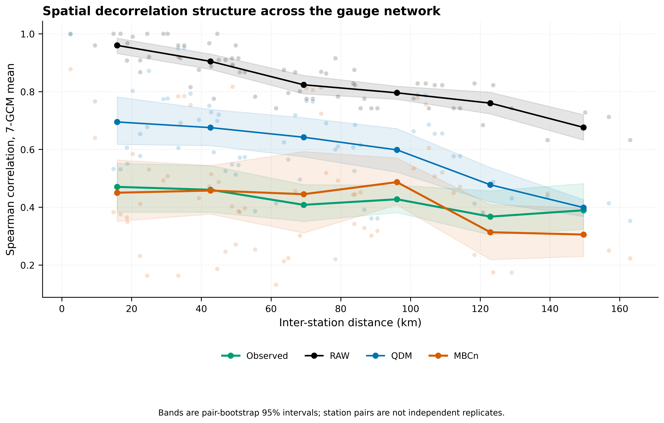
Figure 4. Inter-station Spearman correlation versus gauge separation. MBCn provides the closest overall agreement with the observed distance-decay relationship.

3.3 Spatial organisation of concurrent extremes
The concurrent-extreme analysis supports the dependence result but also demonstrates why the two q95 definitions must be separated. Using normalized station-specific q95, pooled validation RMSE was approximately 0.0134 for raw output, 0.00446 for QDM, and 0.00235 for MBCn. Under observed-threshold sensitivity, the corresponding values were approximately 0.00514, 0.00381, and 0.00237. MBCn therefore provides the clearest improvement in dependence-focused concurrent extremes, while the hazard-oriented metric shows a smaller and model-dependent advantage. The distinction follows the literature on spatially and multivariately compounding hazards and observed precipitation extremes [16], [17], [18], [38].
The network-scale wet-station extent also improved under MBCn. The seven-model mean Wasserstein-1 distance was 0.174 for raw output, 0.107 for QDM, and 0.069 for MBCn. For events affecting at least six of the 12 gauges, observed frequency was 1.93 days yr⁻¹, compared with 3.61 for raw output, 3.55 for QDM, and 1.30 for MBCn. MBCn therefore reduced the excessive frequency of spatially extensive wet events more effectively than QDM, although the corrected frequency remained slightly below observed. Wasserstein distance is appropriate for comparing network-scale distributions [31], whereas energy distance provides a complementary omnibus multivariate discrepancy [30], [34].
The concurrent-extreme analysis supports the dependence result but also demonstrates why the two q95 definitions must be separated. Using normalized station-specific q95, pooled validation RMSE was approximately 0.0134 for raw output, 0.00446 for QDM, and 0.00235 for MBCn. Under observed-threshold sensitivity, the corresponding values were approximately 0.00514, 0.00381, and 0.00237. MBCn therefore provides the clearest improvement in dependence-focused concurrent extremes, while the hazard-oriented metric shows a smaller and model-dependent advantage. The distinction follows the broader literature on spatially and multivariately compounding hazards [27]–[18].
The network-scale wet-station extent also improved under MBCn. The seven-model mean Wasserstein-1 distance was 0.174 for raw output, 0.107 for QDM, and 0.069 for MBCn. For events affecting at least six of the 12 gauges, observed frequency was 1.93 days yr⁻¹, compared with 3.61 for raw output, 3.55 for QDM, and 1.30 for MBCn. MBCn therefore reduced the excessive frequency of spatially extensive wet events more effectively than QDM, although the corrected frequency remained slightly below the observed value. Wasserstein-based comparison is appropriate here because the target is a distribution of network extent rather than a single deterministic threshold [31].

3.4 Numerical behaviour and fidelity to the projected change signal
The iteration sweep did not show a monotonic improvement with increasing passes. Across the three prespecified GCMs, the mean Spearman RMSE fell from 0.276 at zero passes to 0.152 at five passes and 0.149 at ten passes, then oscillated around 0.156–0.164 through 15–100 passes. Mean wet-day occurrence RMSE declined from 0.254 at zero passes to 0.106 at five passes and 0.103 at ten passes, followed by modest oscillations. Thus, most of the dependence adjustment occurred within approximately 5–10 passes. The production value of 25 passes was retained because it was fixed a priori; it should not be described as the empirically optimal iteration count.
Seed sensitivity showed relatively small variability in the primary correlation diagnostics. Across 20 seeds and the three prespecified GCMs, the coefficient of variation was 5.9% for Spearman RMSE and 11.8% for wet-day occurrence RMSE. At the individual-GCM level, mean Spearman RMSE across seeds was 0.152 for ACCESS-ESM1-5, 0.153 for MIROC6, and 0.170 for MRI-ESM2-0. The corresponding wet-occurrence RMSE values were 0.094, 0.110, and 0.124. These results indicate stochastic sensitivity that is modest relative to the QDM-to-MBCn improvement, while also showing that seed dependence should not be assumed to be negligible.
The iteration sweep did not show monotonic improvement. Mean Spearman RMSE fell from 0.276 at zero passes to 0.152 at five passes and 0.149 at ten passes, then oscillated around 0.156–0.164 through 15–100 passes. Mean wet-day occurrence RMSE fell from 0.254 at zero passes to 0.106 at five passes and 0.103 at ten passes. Thus most dependence adjustment occurred within approximately 5–10 passes; the production value of 25 passes was retained because it was fixed a priori and should not be described as the empirical optimum. This interpretation is consistent with methodological cautions that correction strength should not be selected solely by validation error [9], [29], [8].
Seed sensitivity was modest but nonzero. Across 20 seeds and three GCMs, the coefficient of variation was 5.9% for Spearman RMSE and 11.8% for wet-occurrence RMSE. Mean Spearman RMSE across seeds was 0.152 for ACCESS-ESM1-5, 0.153 for MIROC6, and 0.170 for MRI-ESM2-0. Corresponding wet-occurrence RMSE values were 0.094, 0.110, and 0.124. The results support reporting stochastic sensitivity explicitly, consistent with recent comparisons of multivariate correction methods [32].
Future signal preservation was evaluated against the method-consistent 1981–2000 baseline. Across 2,520 gauge–model–scenario–period–quantile cases, mean absolute deviation from the raw projected change signal was 10.32 percentage points for QDM and 9.66 for MBCn. For SSP2-4.5 the values were 8.66 and 8.09; for SSP5-8.5 they were 11.97 and 11.23. Mean correlations between corrected and raw change signals were 0.687 for QDM and 0.654 for MBCn. Neither method reproduced the raw signal exactly. This result should be interpreted in the context of regional CMIP6 uncertainty and the known dependence of projected extremes on correction method [32]–[26], [8], [39].
Temporal diagnostics reveal an important trade-off. MBCn had lower mean absolute error than QDM for lag-1 occurrence autocorrelation (0.072 vs 0.156), lag-3 (0.057 vs 0.075), and lag-30 (0.039 vs 0.054), but it altered persistence-related quantities. CWD error was 18.0 days for MBCn versus 14.6 days for QDM, Rx5day error was 25.1 versus 23.2 mm, and wet-to-wet transition error was 0.117 versus 0.053. Dry-to-dry transition error was similar (0.029 vs 0.025). This trade-off is consistent with recent evidence that no bias-correction method is uniformly superior across marginal, dependence, and temporal properties [32].

Seasonally, MBCn reduced Spearman and wet-occurrence RMSE in all four seasons; the largest Spearman improvement occurred in JJA, from 0.501 under QDM to 0.183 under MBCn. Normalized joint-q95 RMSE improved in DJF and JJA, changed little in MAM, and improved in SON. The seasonal result is relevant to Thailand because monsoon-regime changes strongly influence precipitation intensity and spatial organization [32], [23]–[26].
The evidence supports a context-specific choice rather than a universal ranking. QDM is appropriate when the target is station-level marginal distributions and projected quantile changes [9], [20], [26], [39]. MBCn provides substantially better agreement in the spatial dependence structure of this 12-gauge coastal network, supporting distributed hydrological modelling, spatial hazard mapping, and multivariate risk analysis [10]–[15]. However, temporal diagnostics show that MBCn can alter wet/dry persistence and Rx5day [32].
The evidence supports a context-specific choice rather than a universal ranking. QDM is appropriate when the target is station-level marginal distributions and projected quantile changes [13], [39], [26]. MBCn provides substantially better agreement in the spatial dependence structure of this 12-gauge coastal network, supporting its use for distributed hydrological modelling, spatial hazard mapping, and multivariate risk analysis [11]–[20]. However, temporal diagnostics show that MBCn can alter wet/dry persistence and Rx5day; therefore spatial dependence improvement should not be interpreted as universal improvement in rainfall sequences [32].
A central methodological implication is that marginal validation alone cannot distinguish the present QDM and MBCn formulations because MBCn restores the QDM marginal value set. Dependence diagnostics are therefore necessary whenever corrected gauges are analysed jointly, while temporal diagnostics are necessary for spell, persistence, and multi-day extreme applications [7], [32], [8].

The main limitations are one realization per GCM, a single coastal gauge network, possible nonstationarity of the historical dependence target, residual marginal bias, and the interpretation of seven GCMs as a specified matched ensemble rather than a random population. Additional application context for water-resources planning in Thailand is provided by recent regional studies [40], [38]. Bias correction cannot repair structural model errors or create process realism absent from the driving model [4], [8].
Across 12 Prachuap Khiri Khan rain gauges and seven CMIP6 models, the revised station-locked monthly-block analysis shows a clear separation between marginal and joint performance. QDM and MBCn are identical for the six station-level validation diagnostics by construction, whereas MBCn substantially reduces inter-station dependence errors: 45.1% for Spearman RMSE, 66.8% for Pearson RMSE, 59.2% for wet-day occurrence RMSE, and 52.7% for normalized joint-q95 RMSE relative to QDM. All seven models favour MBCn for the three prespecified primary endpoints, with exact one-sided p = 0.0078 and Holm-adjusted p = 0.0234. Nevertheless, MBCn does not improve every rainfall property: temporal diagnostics show changes in wet/dry persistence and Rx5day, and the observed-threshold q95 sensitivity metric favours MBCn in six of seven models. Future projected wet-day quantile-change fidelity remains broadly comparable between methods. QDM is therefore appropriate when marginal fidelity is sufficient, while MBCn is better supported when inter-station dependence is an explicit requirement, provided that temporal and seasonal consequences are evaluated before downstream hydrological use.

Across 12 Prachuap Khiri Khan rain gauges and seven CMIP6 models, the revised station-locked monthly-block analysis separates marginal from joint performance. QDM and MBCn are identical for the six station-level diagnostics by construction, whereas MBCn reduces Spearman RMSE by 45.1%, Pearson RMSE by 66.8%, wet-day occurrence RMSE by 59.2%, and normalized joint-q95 RMSE by 52.7%. All seven models favour MBCn for the three primary endpoints (exact one-sided p = 0.0078; Holm-adjusted p = 0.0234). Nevertheless, temporal diagnostics show changes in wet/dry persistence and Rx5day, and the observed-threshold q95 sensitivity metric favours MBCn in six of seven models. Future quantile-change fidelity remains broadly comparable. The results support QDM when marginal fidelity is sufficient and MBCn when inter-station dependence is an explicit objective, with temporal validation required before hydrological or extreme-event application [13]–[19], [32], [8].
The author gratefully acknowledges the Thai Meteorological Department for providing observed daily precipitation records.

Author Contributions
Surasit Punyawansiri: conceptualization, methodology, software, validation, formal analysis, data curation, writing, visualization, supervision, and project administration.

Data Availability: Daily rain-gauge records are available from the Thai Meteorological Department subject to its data-sharing conditions; CMIP6 output is publicly available through ESGF. Analysis code and figure data are available from the corresponding author on reasonable request.
This research received no external funding.

Conflicts of Interest
The author declares no conflict of interest.

Data and Code Availability
Data Availability: Daily rain-gauge records are available from the Thai Meteorological Department subject to its data-sharing conditions; CMIP6 output is publicly available through ESGF. Analysis code and figure data are available from the corresponding author on reasonable request.

References
[1] V. Eyring et al., “Overview of the Coupled Model Intercomparison Project Phase 6 (CMIP6) experimental design and organization,” Geosci. Model Dev., vol. 9, no. 5, pp. 1937–1958, 2016, doi: 10.5194/gmd-9-1937-2016.
[2] B. C. O’Neill et al., “The Scenario Model Intercomparison Project (ScenarioMIP) for CMIP6,” Geosci. Model Dev., vol. 9, no. 9, pp. 3461–3482, 2016, doi: 10.5194/gmd-9-3461-2016.
[3] K. Riahi et al., “The Shared Socioeconomic Pathways and their energy, land use, and greenhouse gas emissions implications: An overview,” Glob. Environ. Change, vol. 42, pp. 153–168, 2017, doi: 10.1016/j.gloenvcha.2016.05.009.
[4] D. Maraun, “Bias correcting climate change simulations – a critical review,” Curr. Clim. Change Rep., vol. 2, no. 4, pp. 211–220, 2016, doi: 10.1007/s40641-016-0050-x.
[5] C. Teutschbein and J. Seibert, “Bias correction of regional climate model simulations for hydrological climate-change impact studies: Review and evaluation of different methods,” J. Hydrol., vols. 456–457, pp. 12–29, 2012, doi: 10.1016/j.jhydrol.2012.05.052.
[6] L. Gudmundsson, J. B. Bremnes, J. E. Haugen, and T. Engen-Skaugen, “Technical Note: Downscaling RCM precipitation to the station scale using statistical transformations – a comparison of methods,” Hydrol. Earth Syst. Sci., vol. 16, no. 9, pp. 3383–3390, 2012, doi: 10.5194/hess-16-3383-2012.
[7] D. Maraun et al., “VALUE: A framework to validate downscaling approaches for climate change studies,” Earth’s Future, vol. 3, no. 1, pp. 1–14, 2015, doi: 10.1002/2014EF000259.
[8] D. Maraun et al., “Towards process-informed bias correction of climate change simulations,” Nat. Clim. Change, vol. 7, no. 11, pp. 764–773, 2017, doi: 10.1038/nclimate3418.
[9] A. J. Cannon, S. R. Sobie, and T. Q. Murdock, “Bias correction of GCM precipitation by quantile mapping: How well do methods preserve changes in quantiles and extremes?” J. Clim., vol. 28, no. 17, pp. 6938–6959, 2015, doi: 10.1175/JCLI-D-14-00754.1.
[10] A. J. Cannon, “Multivariate bias correction of climate model output: Matching marginal distributions and intervariable dependence structure,” J. Clim., vol. 29, no. 19, pp. 7045–7064, 2016, doi: 10.1175/JCLI-D-15-0679.1.
[11] A. J. Cannon, “Multivariate quantile mapping bias correction: An N-dimensional probability density function transform for climate model simulations of multiple variables,” Clim. Dyn., vol. 50, nos. 1–2, pp. 31–49, 2018, doi: 10.1007/s00382-017-3580-6.
[12] M. Vrac, “Multivariate bias adjustment of high-dimensional climate simulations: The Rank Resampling for Distributions and Dependences (R2D2) bias correction,” Hydrol. Earth Syst. Sci., vol. 22, no. 6, pp. 3175–3196, 2018, doi: 10.5194/hess-22-3175-2018.
[13] Y. Robin, M. Vrac, P. Naveau, and P. Yiou, “Multivariate stochastic bias corrections with optimal transport,” Hydrol. Earth Syst. Sci., vol. 23, no. 2, pp. 773–786, 2019, doi: 10.5194/hess-23-773-2019.
[14] B. François, M. Vrac, A. J. Cannon, Y. Robin, and D. Allard, “Multivariate bias corrections of climate simulations: Which benefits for which losses?” Earth Syst. Dyn., vol. 11, no. 2, pp. 537–562, 2020, doi: 10.5194/esd-11-537-2020.
[15] W. Kleiber, R. W. Katz, and B. Rajagopalan, “Daily spatiotemporal precipitation simulation using latent and transformed Gaussian processes,” Water Resour. Res., vol. 48, no. 1, W01523, 2012, doi: 10.1029/2011WR011105.
[16] E. Bevacqua et al., “Advancing research on compound weather and climate events via large ensemble model simulations,” Nat. Commun., vol. 14, 2145, 2023, doi: 10.1038/s41467-023-37847-5.
[17] J. Zscheischler et al., “A typology of compound weather and climate events,” Nat. Rev. Earth Environ., vol. 1, no. 7, pp. 333–347, 2020, doi: 10.1038/s43017-020-0060-z.
[18] N. N. Ridder et al., “Global hotspots for the occurrence of compound events,” Nat. Commun., vol. 11, 5956, 2020, doi: 10.1038/s41467-020-19639-3.
[19] S. Supharatid, J. Nafung, and T. Aribarg, “Projected changes in temperature and precipitation over mainland Southeast Asia by CMIP6 models,” J. Water Clim. Change, vol. 13, no. 1, pp. 337–356, 2022, doi: 10.2166/wcc.2021.015.
[20] X. Qin and C. Dai, “Comparison of different quantile delta mapping schemes in frequency analysis of precipitation extremes over mainland Southeast Asia under climate change,” J. Hydrol., vol. 606, 127421, 2022, doi: 10.1016/j.jhydrol.2021.127421.
[21] S. Try and X. Qin, “Evaluation of future changes in climate extremes over Southeast Asia using downscaled CMIP6 GCM projections,” Water, vol. 16, no. 15, 2207, 2024, doi: 10.3390/w16152207.
[22] U. W. Humphries, M. Waqas, P. T. Hlaing, P. Dechpichai, and A. Wangwongchai, “Assessment of CMIP6 GCMs for selecting a suitable climate model for precipitation projections in Southern Thailand,” Results Eng., vol. 23, 102417, 2024, doi: 10.1016/j.rineng.2024.102417.
[23] S. Rojpratak and S. Supharatid, “Regional extreme precipitation index: Evaluations and projections from the multi-model ensemble CMIP5 over Thailand,” Weather Clim. Extremes, vol. 37, 100475, 2022, doi: 10.1016/j.wace.2022.100475.
[24] D. Khadka, M. S. Babel, M. Collins, S. Shrestha, S. G. P. Virdis, and A. S. Chen, “Projected changes in the near-future mean climate and extreme climate events in Northeast Thailand,” Int. J. Climatol., vol. 42, no. 4, pp. 2470–2492, 2022, doi: 10.1002/joc.7377.
[25] D. Kuinkel, P. Promchote, K. R. Upreti, S.-Y. Wang, N. Dahal, and B. Pokharel, “Projected changes in precipitation extremes in Southern Thailand using CMIP6 models,” Theor. Appl. Climatol., vol. 155, no. 9, pp. 8703–8716, 2024, doi: 10.1007/s00704-024-05150-y.
[26] Y. H. Song and E.-S. Chung, “Comparison of quantile mapping methods for daily precipitation correction and future projections under the SSP5-8.5,” J. Korea Water Resour. Assoc., vol. 57, no. 12, pp. 1069–1083, 2024, doi: 10.3741/JKWRA.2024.57.12.1069.
[27] S. I. Seneviratne et al., “Weather and climate extreme events in a changing climate,” in Climate Change 2021: The Physical Science Basis, Cambridge, U.K.: Cambridge Univ. Press, 2021, pp. 1513–1766, doi: 10.1017/9781009157896.013.
[28] D. S. Wilks, Statistical Methods in the Atmospheric Sciences, 3rd ed. Academic Press, 2011.
[29] S. E. Perkins, A. J. Pitman, N. J. Holbrook, and J. McAneney, “Evaluation of the AR4 climate models’ simulated daily maximum temperature, minimum temperature, and precipitation over Australia using probability density functions,” J. Clim., vol. 20, no. 17, pp. 4356–4376, 2007, doi: 10.1175/JCLI4253.1.
[30] G. J. Székely and M. L. Rizzo, “Energy statistics: A class of statistics based on distances,” J. Stat. Plan. Inference, vol. 143, no. 8, pp. 1249–1272, 2013, doi: 10.1016/j.jspi.2013.03.018.
[31] C. Villani, Optimal Transport: Old and New. Berlin, Germany: Springer, 2009, doi: 10.1007/978-3-540-71050-9.
[32] S. Sharma, A. S. Raghuvanshi, and A. Agarwal, “Evaluating the performance of uni- and multivariate bias correction techniques: Challenges in preserving temporal and dependence structures,” Water Resour. Res., vol. 62, no. 2, e2025WR041526, 2026, doi: 10.1029/2025WR041526.
[33] D. Dieng et al., “Multivariate bias-correction of high-resolution regional climate change simulations for West Africa: Performance and climate change implications,” J. Geophys. Res. Atmos., vol. 127, no. 8, e2021JD034836, 2022, doi: 10.1029/2021JD034836.
[34] M. L. Rizzo and G. J. Székely, “Energy distance,” Wiley Interdiscip. Rev. Comput. Stat., vol. 8, no. 1, pp. 27–38, 2016, doi: 10.1002/wics.1375.
[35] J. Kyselý, “A cautionary note on the use of nonparametric bootstrap for estimating uncertainties in extreme-value models,” J. Appl. Meteorol. Climatol., vol. 47, no. 12, pp. 3236–3251, 2008, doi: 10.1175/2008JAMC1763.1.
[36] F. Wilcoxon, “Individual comparisons by ranking methods,” Biometrics Bull., vol. 1, no. 6, pp. 80–83, 1945, doi: 10.2307/3001968.
[37] S. Holm, “A simple sequentially rejective multiple test procedure,” Scand. J. Stat., vol. 6, no. 2, pp. 65–70, 1979.
[38] L. V. Alexander et al., “Global observed changes in daily climate extremes of temperature and precipitation,” J. Geophys. Res. Atmos., vol. 111, D05109, 2006, doi: 10.1029/2005JD006290.
[39] K. Tedprasith and W. Lohpaisankrit, “Development of intensity-duration-frequency relationships in Khon Kaen City, Thailand under changing climate using GCMs and a simple scaling method,” J. Water Clim. Change, vol. 15, no. 3, pp. 1204–1217, 2024, doi: 10.2166/wcc.2024.533.
[40] J. Srinate and R. Hormwichian, “Modeling future water deficit trends under varying climate change projections in Huai-SamMor Basin, Thailand,” Engineering Access, vol. 12, no. 1, pp. 51–62, 2025/2026, doi: 10.14456/mijet.2026.6.

